

[Lovely Professional University](http://www.lpu.in/)

B Tech



Marketing Website

*A project submitted in fulfilment of the requirements for the subject CSE 326*

Department of Computer Science

School of Computer Science Engineering

*Submitted by: Supervisor:*

**Ms. Upinder Kaur**

Perla Vikunth Rao ( B83 )

Kalyani Rajesh Parayil ( B84 )

Aryan Srivastava ( B85 )

**INTRODUCTION**

The project is established with the goal of honing and testing our skills based on the curriculum we learned during the semester. We were given the task of creating a basic marketing website.

Through group discussions and multiple late-night calls, we finally have a website to present to you called TINEID.

Marketing is the process of exploring, creating, and delivering value to meet the needs of a target in terms of goods and services. Based on this we created a website which meets the basic requirements of marketing for a company based on Logo Designing.

We created TINEID with the goal of giving ideas a face. Our combined understanding of html, CSS, and JavaScript has resulted in the creation of this website. The website is simple, but we've worked hard to make it functional and easy to use. The majority of the website is made up of html and CSS, with a small amount of JavaScript thrown in for good measure. We attempted to make our website elegant using CSS and we've managed to have a consistent color palette throughout the website which makes it more eye-catching and vibrant.

Our work has reflected our united efforts and collaboration. TINEID is the culmination of our efforts and sleepless nights. We hope this website will catch your eye like it did for us not just the eye but your heart too . We'd like to express our gratitude to our mentor for helping us reach a place where we can create a website on our own. We are avidly anticipating the outcomes.

**OBJECTIVES**

TINEID is a logo designing company which was initiated in the year 2021.

The core purpose of a TINEID is to give your company an identity

so you can grow your business by capturing new clients with a logo that speaks to them.

1.BRAND IMAGE

Every business starts with a brand image,

which encapsulates your company’s vision and overall identity.

That brand image is represented by a logo the public can identify with and remember your business by.

That logo, which is expressing your company’s vision,

is seen everywhere from your stationery to your website to any advertising done—it is a company’s visual identity.

A logo also reminds your clients or potential clients that you exist, what you stand for, and how you stand apart from the competition.

TINEID aims to give the customers the BRAND IMAGE which will be the face of your ideas and uniqueness.

2.ATTENTION

It’s most important to have a logo that catches people’s attention,

one that is *memorable, simple, and carefully crafted*

so that when people see if for the first time, they relate to it on a personal level,

they connect with it. Capturing first impressions is the most important part of your branding; if your logo doesn’t speak to its audience neither can you.

OUR COMPANY intends to give our customers the *ATTENTION* seeking factor through the logo we design.

3.GROWTH

A logo helps your company grow when it reaches the right audience.

Your company’s identity is represented by your logo and in this noisy world, it must stand out.

If your logo is done well, it will show that you care and can be trusted

so your customers and clients will know that you care about your business.

TINEID aims to contribute to the growth of its customers through

carefully and dynamically crafted logos.

4.SIMPLICITY

Simplicity is what helps a logo stand up against challenges of time

and what makes it replicable and easy to work with.

The logo should be as clear and visible as possible while reflecting your aesthetics and conveying your philosophy.

Wise choices in typeface, color options and graphics are crucial to this step.

SO, here in TINEID you can work with one of the best design team

who keep the simplicity as it is and make your company to stand out

the market challenges

5.ORIGINALITY

A unique logo design calls for a unique design concept.

This is the point in logo design where artistry meets great ideas and a firm grasp of consumer design.

That's what we offer you in TINEID.

The logo needs to be different enough to attract attention and memorable enough to remain in people’s minds.

Successful logos stand out from the crowd by being different, original and memorable.

The logo must attract a first glance that people will remember and then express trust and reliability upon repeat interactions.

SO, here in TINEID we keep the soul of your mottos and objectives hence keeping the

ORIGINALITY of the logo that makes the face of your company(logo) unique.

**FLOWCHART**

**INDIVIDUAL WORK**

**ARYAN’S WORK:**

ABOUT US PAGE:

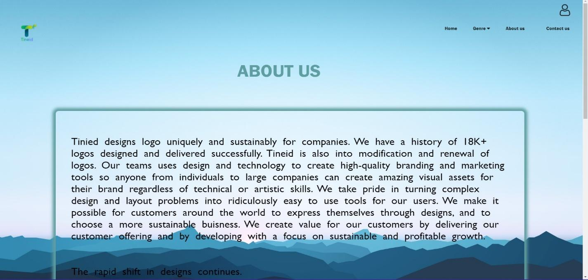

QUERY FORM:

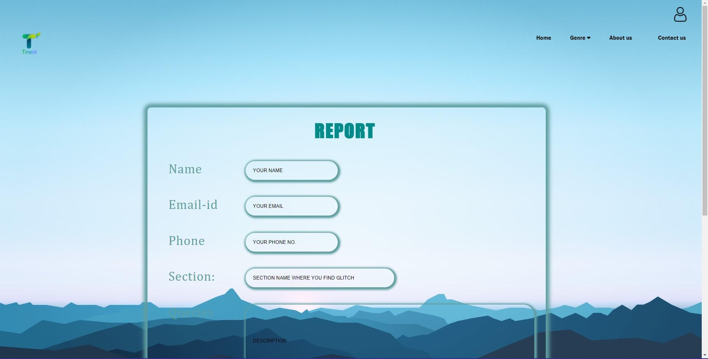

GENRE PAGE:

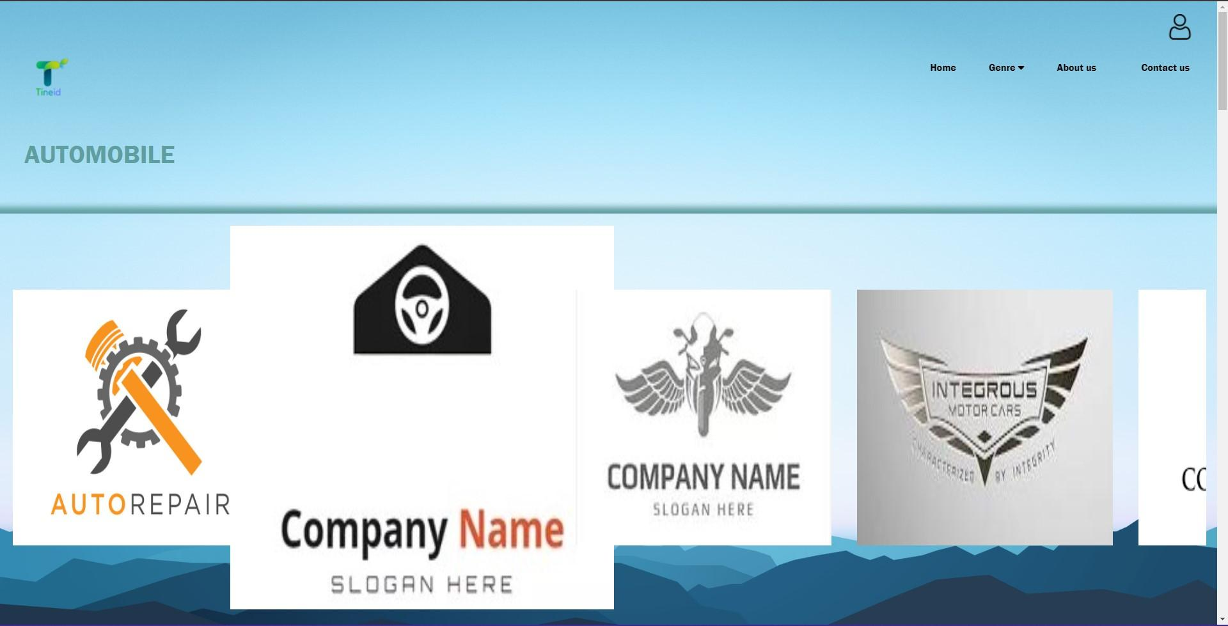

**VIKUNTH’S WORK:**

POLICY PAGE:

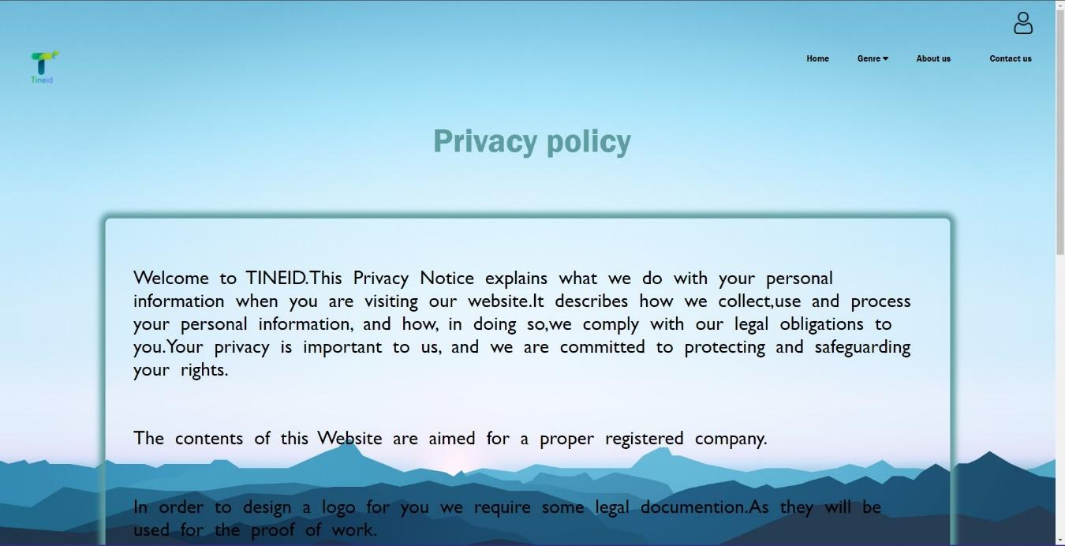

CONTACT PAGE:

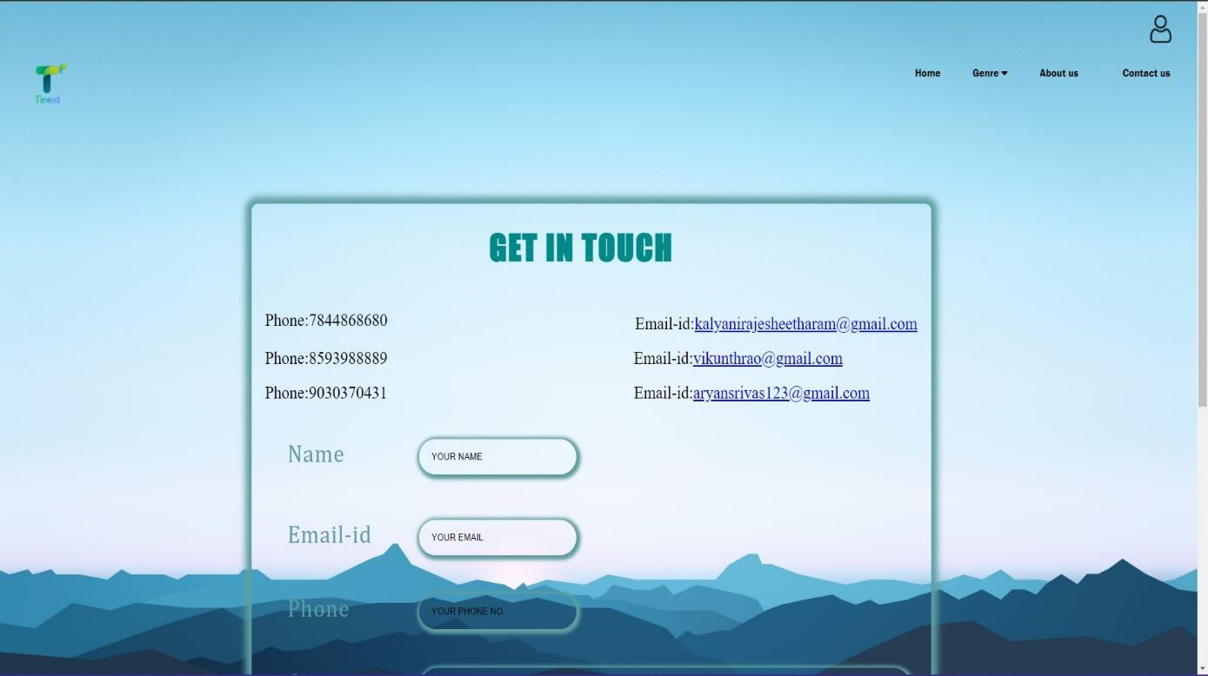

CAREER PAGE:

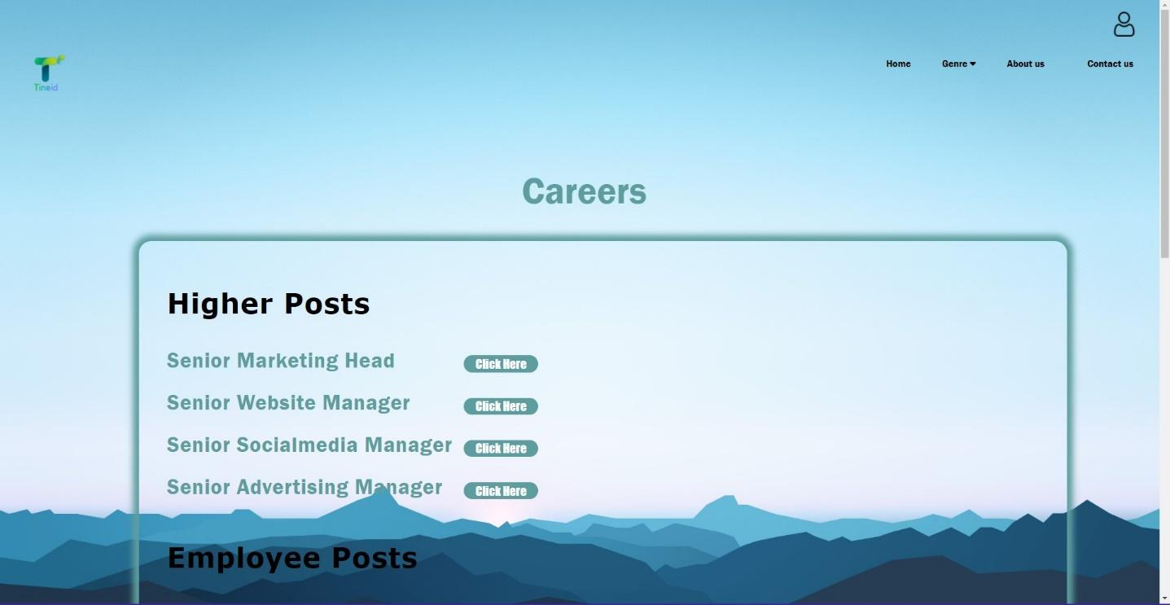

**KALYANI’S WORK:**

DESIGNATION FORM:

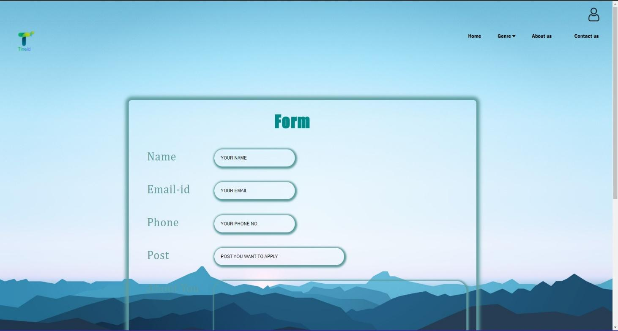

TERMS AND CONDITION PAGE:

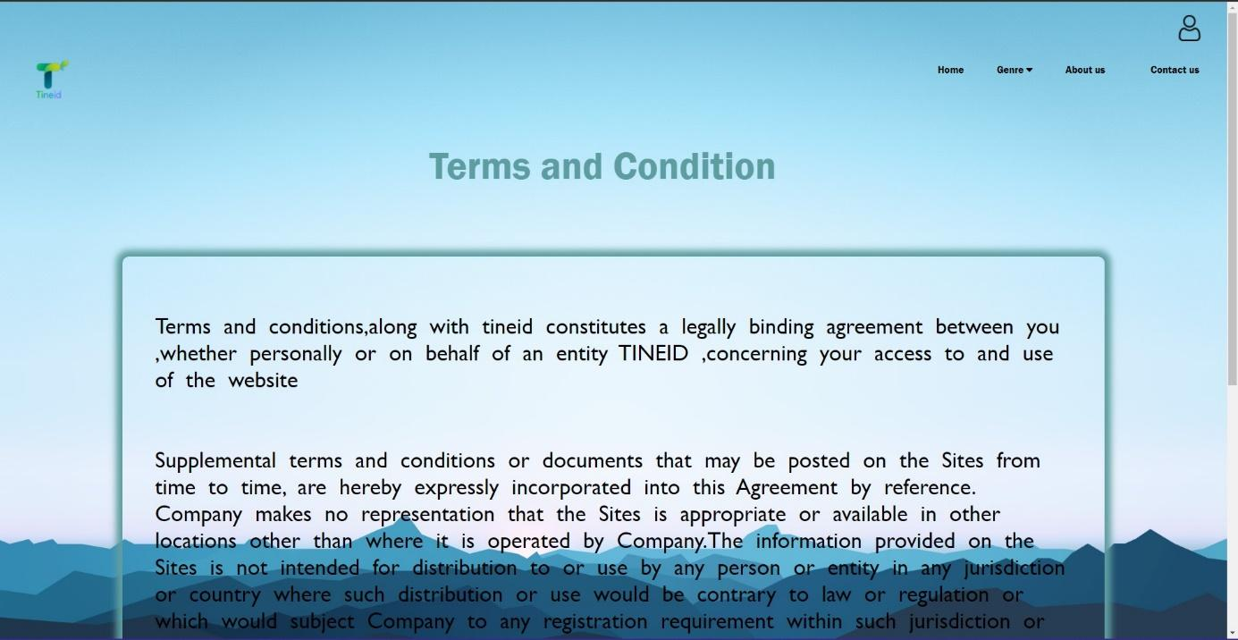

FAQ PAGE:

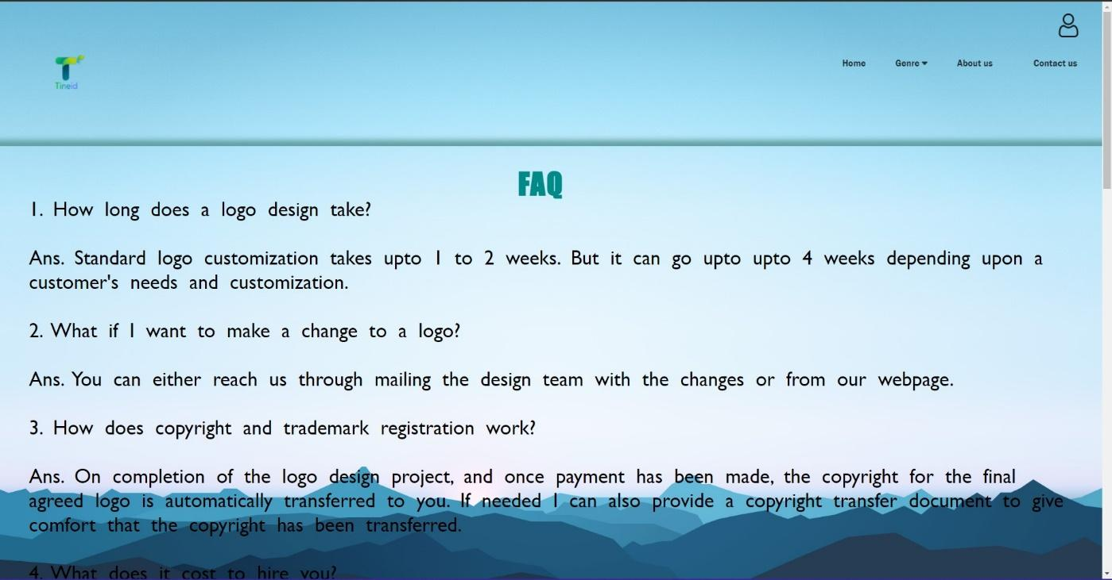

**GROUP WORK:**

HOME PAGE:

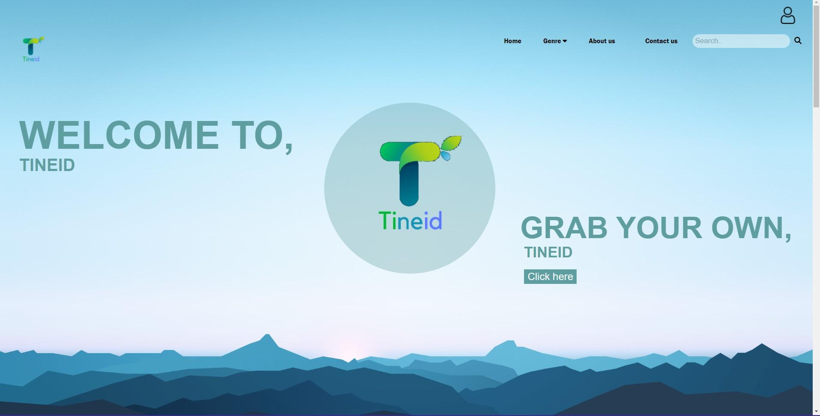

LOGIN PAGE:

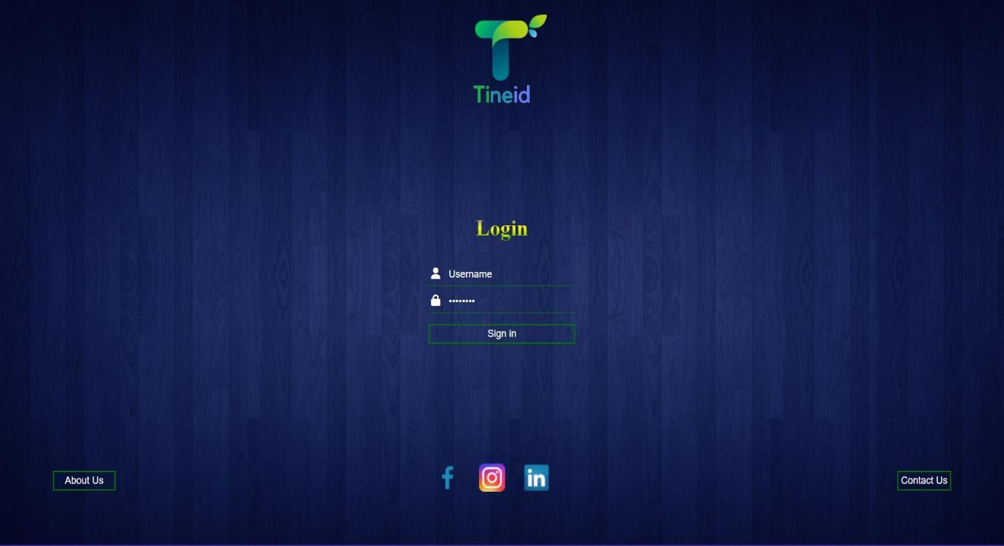

**CONCLUSION AND FUTURE SCOPE**

Tineid is the result of the topic we were assigned, as stated throughout the report, and seen on our website. We did our best to make it as functional as possible and a little bit of classiness to catch your eye.

Today, logo design is a huge market, and as the market grows, so does the scope for it, indicating TINEID's future potential. When a user visits a website, the logo is the first thing that captures their attention. A creative business owner is continually thinking of new methods to increase the company's relationship with the target audience's ever-changing behavior and logos appear to connect with the target audience more than any other strategy. As a result, we hope TINEID will bear its fang as one of the top companies in case it ever comes into reality.

**References**

* <https://www.loungelizard.com/about/>
* <https://www.pkgbranding.com/>
* <https://www.wipro.com/>
* <https://evestar.com/>
* <https://www.w3schools.com/>
* <https://www.forbes.com/billionaires/>
* <https://www.looka.com/>
* <https://www.canva.com/>
* <https://www.hotstar.com/in>
* <https://htmlcolorcodes.com/>
* <https://www.w3schools.com/colors/colors_picker.asp>
* <https://www.visme.co/flowchart-maker/>
* <https://html-color.codes/image>
* <https://www.w3schools.com/cssref/tryit.asp?filename=trycss3_image_gallery>
* <https://meet.google.com/>
* <https://login.microsoftonline.com/>
* <https://www.geeksforgeeks.org/>
* <https://www.javatpoint.com/>
* <https://www.youtube.com/>
* <https://www.shutterstock.com/>
* <https://www.vectorstock.com/>
* <https://www.instagram.com/>
* Kimberly page layout

PERLA VIKUNTH RAO - B83

KALYANI RAJESH PARAYIL - B84

ARYAN SRIVASTAVA - B85